2023-2024 | By: Soham Manjrekar, Shaikh Mudasser Ali, Mohammed Baquir Sayed, Siddiqui Adaab Husain



CodeConnect- The

Ultimate Social Platform



Rizvi College of Engineering Department of Computer Engineering Major Project Synopsis Report

On

# CodeConnect- The Ultimate Social Platform for Coders

Submitted in partial fulfilment of the requirements of the Major-Project of Fourth Year of

Bachelors of Engineering by

Soham Shrikant Manjrekar (UIN:201P018)

Shaikh Mudasser Ali (UIN:201P063)

Mohammed Baquir Sayed (UIN:201P055)

Siddiqui Adaab Husain (UIN: 201P004)

………….……………………………………………..

Guide:

Prof. Reshma Lohar

University of Mumbai



2023-2024

# CERTIFICATE

This is to certify that the project synopsis entitled “**CodeConnect- The Ultimate Social Platform for Coders**” has been submitted by Soham Shrikant Manjrekar, Shaikh Mudasser Ali, Mohammed Baquir Sayed And Siddiqui Adaab Husain under the guidance of Prof. Reshma Lohar **in** partial fulfilment of the requirement for the award of the Degree of Bachelor of Engineering in Computer Engineering from University of Mumbai.

Certified By

Prof. Reshma Lohar Prof. Shiburaj Pappu Dr. Anupam Choudhary Project Guide Dean Head of Department

Prof. Prof.

Internal Examiner External Examiner

Dr. Varsha Shah Principal



Department of Computer Engineering

##### Rizvi College of Engineering,

Off Carter Road, Bandra(W), Mumbai-400050

DECLARATION

We declare that this written submission represents my ideas in my own words and where others' ideas or words have been included, we have adequately cited and referenced the original sources. We also declare that I have adhered to all principles of academic honesty and integrity and have not misrepresented fabricated or falsified any idea/data/fact/source in my submission. We understand that any violation of the above will be cause for disciplinary action by the Institute and can also evoke penal action from the sources that have thus not been properly cited or from whom proper permission has not been taken when needed.

Soham Shrikant Manjrekar (UIN:201P018)

Shaikh Mudasser Ali (UIN:201P063)

Mohammed Baquir Sayed (UIN:201P055)

Siddiqui Adaab Husain (UIN: 201P004)

Date:

**ABSTRACT**

Reflecting the spirit of an industry where teamwork is often paramount, a dedicated space for developers to showcase their joint endeavors takes center stage in project collaboration. Through this feature, a sense of community is fostered and collaborative innovation is encouraged, all while highlighting the unique capabilities of each team member.

CodeConnect's learning center is a knowledge-sharing hub that offers a diverse array of tutorials and resources from industry experts. Its AI-driven job recommendation system exposes developers to opportunities that align with their skills and aspirations, demonstrating the platform's commitment to continuous learning. This feature goes beyond networking, adding an educational richness to the CodeConnect experience.

Beyond the typical networking offerings, CodeConnect offers a unique mentorship initiative. With experienced developers guiding those just starting out, the focus is on cultivating skills and career advancement while fostering a tight-knit community and collective progress.

**Keywords:** Python, Django, MySQL, CSS, HTML, Nextjs, Tailwind CSS.

# INDEX

|  |  |  |
| --- | --- | --- |
| **SR. NO** | **TITLE** | **Page No.** |
| 1 | INTRODUCTION | 9 |
|  | * 1. PURPOSE   2. SCOPE   3. OBJECTIVES   4. LIST OF ABBREVIATIONS |  |
| 2 | LITERATURE SURVEY | 11 |
|  | * 1. INTRODUCTION   2. SOCIAL MEDIA PLATFORMS FOR DEVELOPERS   3. CODING COMMUNITIES AND FORUMS   4. COLLABORATIVE CODING PLATFORMS   5. SURVEY OF EXISTING SYSTEM |  |
| 3 | OVERALL DESCRIPTION | **15** |
|  | * 1. PRODUCT PERSPECTIVE   2. PRODUCT FEATURES AND FUNCTIONS   3. USER CLASSES AND CHARACTERISTICS   4. OPERATING ENVIRONMENT   5. DESIGN AND IMPLEMENTATION CONSTRAINTS   6. USER DOCUMENTATION   7. ASSUMPTIONS AND DEPENDENCIES |  |
| 4 | SPECIFIC REQUIREMENTS | **19** |
|  | * 1. EXTERNAL INTERFACE REQUIREMENTS   2. FUNCTIONAL REQUIREMENTS |  |

|  |  |  |
| --- | --- | --- |
|  | 4.3. NON-FUNCTIONAL REQUIREMENTS |  |
| 5 | SYSTEM DESIGN CONSTRAINTS | **24** |
|  | * 1. TECHNOLOGY STACK AND ARCHITECTURE   2. PLATFORM COMPATIBILITY AND RESPONSIVENESS   3. COMPONENT DIAGRAM   4. SEQUENCE DIAGRAM |  |
| 6 | DATABASE DESIGN | **27** |
|  | * 1. DATABASE SCHEMA   2. COLLABORATIVE CODING   3. EVENTS AND OPPORTUNITIES   4. CONTENT CREATION |  |
| 7 | SYSTEM QUALITY ATTRIBUTES | **31** |
|  | * 1. MAINTAINABILITY   2. PORTABILITY   3. TESTABILITY |  |
| 8 | EXTERNAL DEPENDENCIES | **32** |
|  | * 1. THIRD-PARTY APIS AND SERVICES   2. INTEGRATION WITH OTHER PLATFORMS |  |
| 9 | IMPLEMENTATION PLAN | **33** |
|  | * 1. GANTT CHART   2. FUTURE SCOPE   3. User Interface |  |
|  | CONCLUSION | **38** |
|  | ACKNOWLEDGMENTS | **39** |
|  | REFERENCES | **40** |

**List of Figures**

|  |  |  |
| --- | --- | --- |
| **Fig No.** | **Title** | **Page no** |
| 1 | Fig 1: Component Diagram - Represents the high-level components in the system and their interactions | 25 |
| 2 | Fig 2 : Sequence Diagram - Displays the chronological sequence of interactions between component | 26 |
| 3 | Fig 3: ER Diagram | 30 |
| 4 | Fig 4 :Gantt chart | 33 |
| 5 | Fig 5 : Project Flow diagram | 34 |
| 6 | Fig 6 : user interface | 37 |

1. **INTRODUCTION**
   1. **Purpose**

The primary purpose of CodeConnect is to address the unique challenges and requirements of professionals within the coding and development community. Traditional social media platforms often lack the specificity needed for developers to effectively connect, collaborate, and showcase their technical prowess. CodeConnect aims to fill this gap by offering a dedicated space where individuals in the coding world can not only network but also find valuable resources, collaborate on projects, and advance their careers.

### Scope

The scope of CodeConnect extends beyond generic professional networking. While traditional platforms focus on broader professional interests, CodeConnect zooms in on the technical aspects of its users. From detailed developer profiles to specialized coding challenges, the platform seeks to cover the entire spectrum of a developer's professional journey. This includes learning resources, collaborative coding opportunities, and even AI-driven job recommendations tailored to individual skill sets.

### Objectives

#### Community Building

CodeConnect aims to cultivate a vibrant and engaged community of developers. By providing a platform that understands and caters to their unique needs, the objective is to foster meaningful connections amongprofessionals in the coding world.

#### Collaboration Hub

One of the primary goals is to create a collaborative hub where developers can seamlessly work together on projects. The platform facilitates project showcases, enabling users to demonstrate their collaborative efforts and achievements.

#### Learning Ecosystem

The Code Learning Center stands as a testament to the commitment to continuous learning. The objective is to provide a rich repository of coding tutorials, articles, and resources contributed by industry professionals, ensuring that users stay updated with the latest technologies.

#### Career Development

#### Beyond mere networking, CodeConnect incorporates an AI-powered job recommendation system. This ambitious objective is to enhance career development by connecting developers with opportunities that align with their specific skills, experiences, and aspirations.

#### Recognition and Endorsements

The introduction of Tech Stack Badges signifies a commitment to recognizing and rewarding expertise. By allowing users to earn and endorse these badges, the platform aims to establish a culture of acknowledgment within the community.

GitHub Project Link: https://github.com/sohammanjrekar/CodeConnect--The-Ultimate-Social-Platform-for- Coders

### List of abbreviations

Terminology Meaning

ERD Entity Relationship Diagram

DFD Data Flow Diagram

HTTP Hyper Text Transfer Protocol

SQL Structure Query Language

DBMS Database Management System

IDE Integrated Development Environment

## LITERATURE SURVEY

### Introduction

The literature survey provides an overview of existing research, articles, and publications relevant to social media platforms for developers, coding communities, and collaborative coding environments. This survey aims to understand the existing landscape, identify trends, and pinpoint areas where CodeConnect can bring innovation.

### Social Media Platforms for Developers

#### LinkedIn as a Professional Network

LinkedIn has been a pioneer in connecting professionals across various industries. For developers, it serves as a platform to showcase their skills, connect with peers, and explore job opportunities. However, its generic nature lacks a specialized focus on coding and collaborative coding practices.

#### GitHub for Code Collaboration

GitHub is synonymous with version control and collaborative coding. It excels in hosting and managing Git repositories, enabling developers to collaborate on projects. While it's a crucial tool for coding collaboration, it doesn't provide the social networking aspects found in platforms like LinkedIn.

### Coding Communities and Forums

#### Stack Overflow for Q&A

Stack Overflow has become the go-to platform for developers seeking answers to coding questions. It emphasizes a question-and-answer format and has a vast community of developers. However, it lacks the social networking and profile-building aspects found in broader social media platforms.

#### Reddit's Coding Subreddits

Reddit hosts various subreddits dedicated to coding, programming languages, and technology discussions. While it fosters a sense of community and knowledge sharing, it lacks the structured profile-building features found in dedicated professional networks.

### Collaborative Coding Platforms

#### Visual Studio Live Share

Visual Studio Live Share enables real-time collaborative coding within the Visual Studio Code environment. It's an excellent tool for pair programming but doesn't extend to providing a broader social media experience.

#### GitLab's Integrated Environment

GitLab offers an integrated environment for the entire DevOps lifecycle, including source code management, continuous integration, and collaboration. However, its primary focus is on project management and collaboration rather than social networking.

### Survey of Existing system

We studied 03 papers relevant to our project. These papers helped us review the already existing Social Media application and also study the features which can be implemented in our project.

#### Paper 1: Survey of Existing system

In their paper "Social Media for Software Engineering," published in November 2010, Andrew Begel, Robert DeLine, and Thomas Zimmermann delve into the transformative potential of social media in the field of software development. They envision a paradigm shift where social media platforms enable software teams to form and collaborate in novel ways, facilitating the emergence of grassroots development communities. Moreover, the paper highlights the capacity of lone individuals and small companies to leverage social media for the entire product development lifecycle, from conception to deployment, potentially leading to successful and profitable product lines.

The authors emphasize the role of researchers in this evolving landscape, stressing the need for methods that safeguard the privacy and reputation of the stakeholders engaged in these novel software development processes.

Additionally, the paper draws parallels between the social dynamics in software development and established teaming models, such as Tuckman and Jensen's stages of forming, storming, norming, performing, and adjourning. This connection underscores the significance of engineers finding like-minded individuals with shared goals, harmonizing communication and collaboration preferences, and addressing the challenges that may arise during the software development lifecycle.

#### Paper 2: Programming in a Socially Networked World: the Evolution of the Social Programmer

In their 2012 paper titled "Programming in a Socially Networked World: the Evolution of the Social Programmer," Christoph Treude, Fernando Figueira Filho, Brendan Cleary, and Margaret-Anne Storey discuss the profound impact of social media on the way software developers collaborate, coordinate their work, and access information. They emphasize the role of social media, such as Stack Overflow's Q&A portal, in reshaping the software development landscape by creating vast archives of information covering a wide array of topics.

Social media platforms like Stack Overflow have become invaluable resources for developers, offering reusable code snippets, usage examples, libraries, and a wealth of knowledge that is just a web search away. The authors delve into the opportunities and challenges faced by software developers who rely on crowd-curated web content. They envision a future in which individual developers both benefit from and contribute to a collective body of knowledge maintained by the crowd through social media.

Stack Overflow, for instance, has played a pivotal role in facilitating knowledge exchange among software developers, with millions of questions and answers and a real-time community ready to assist. This accessibility to a vast repository of knowledge raises important questions about developers' understanding of software intricacies, coverage of all aspects of a topic by web resources, metadata requirements for technical information retrieval, and addressing security and copyright concerns associated with using other developers' code.

#### Paper 3: Codebook: Social Networking over Code

In their 2009 paper titled "Codebook: Social Networking over Code," Andrew Begel and Robert DeLine, from Microsoft Research, introduce an innovative concept in software engineering that harnesses the power of social networking. They highlight how social networking systems have transformed the way people maintain connections with friends, enabling awareness, communication, and collaboration, especially when separated by distance. In contrast to conventional social networking, where people connect with each other, the authors propose a novel approach. They present "Codebook," a social networking web service that allows individuals to establish connections not only with other people but also with the work artifacts they share.

Codebook provides a web interface that visualizes the connections between people and the work artifacts they collaborate on, offering software engineers a means to track task dependencies, discover and maintain connections with other teams, and gain a comprehensive understanding of the history and rationale behind the code they work on and use.

By drawing inspiration from popular social networking services like LinkedIn, MySpace, and Facebook, the authors introduce Codebook as a tool designed to help software engineers coordinate and track activities. Similar to how Facebook users declare each other as "friends" and stay informed about each other's activities, Codebook allows software engineers to track colleague activities and changes in the status of work artifacts. Additionally, Codebook serves as an information portal, offering engineers basic information about people and work artifacts, including their history. This innovative approach promises to improve coordination and collaboration within software development teams by applying social networking principles to work artifacts and activities.

## OVERALL DESCRIPTION

* 1. **Product Perspective**

CodeConnect is positioned as a standalone platform, providing a focused and specialized environment for developers. In the broader context, it complements existing social media platforms by addressing the unique needs of the coding community. While traditional platforms offer generic professional networking, CodeConnect takes a step further by integrating features specifically designed for developers, including Tech Stack Badges, collaborative project showcases, and an AI-driven job recommendation system.

### Product Features and Functions

#### Developer Profiles and Portfolios

The core feature of CodeConnect is the elaborate developer profiles and portfolios. Users can showcase their coding skills, projects, certifications, and work experiences. This feature is designed to go beyond a typical professional profile, emphasizing technical expertise and allowing users to highlight proficiency in programming languages, frameworks, and technologies.

#### Tech Stack Badges and Endorsements

CodeConnect introduces a novel approach to recognizing expertise through Tech Stack Badges. Users can earn these badges based on their proficiency in specific tech stacks, and other users can endorse these badges, creating a system of acknowledgment and validation within the community.

#### Code Collaboration and Projects Showcase

Facilitating collaboration is a key aspect of CodeConnect. Users can form teams, collaborate on coding projects, and showcase the outcomes on their profiles. This feature not only encourages teamwork but also provides a platform for users to exhibit their collaborative achievements.

#### Coding Communities and Groups

To encourage discussions and interactions among like-minded individuals, CodeConnect incorporates coding communities and groups. These specialized groups allow users to join discussions, share insights, and connect with others based on shared interests and programming languages.

#### Code Learning Center

Recognizing the importance of continuous learning in the tech industry, CodeConnect includes comprehensive Code Learning Center. Here, users can access coding tutorials, online courses, and resources contributed by industry professionals, fostering a culture of knowledge sharing.

#### AI-Powered Job Recommendations

A standout feature of CodeConnect is its AI-driven job recommendation system. By analyzing users' profiles, skills, and career interests, the platform suggests job opportunities tailored to individual coding expertise. This feature aims to streamline the job search process for developers.

#### Virtual Tech Events and Webinars

To further enhance networking and knowledge-sharing opportunities, CodeConnect hosts virtual tech events, webinars, and tech talks. Users can attend these events, participate in discussions, and stay updated with the latest trends and advancements in the tech industry.

#### Code Challenges and Hackathons

CodeConnect organizes regular coding challenges and hackathons, providing a platform for developers to test their skills, compete, and gain recognition. These events contribute to skill enhancement and community engagement.

#### Developer Blogging Platform

Recognizing the importance of thought leadership, CodeConnect includes a blogging platform where users can publish coding-related articles, tutorials, and insights. This feature contributes to community- driven knowledge sharing and establishes users as industry influencers

#### CodeConnect Mentorship Program

To foster mentorship within the community, CodeConnect introduces a mentorship program. Experienced developers can mentor aspiring ones, providing career guidance and skill development opportunities.

#### Secure Networking and Collaboration

Prioritizing user privacy and data security, CodeConnect includes robust privacy settings. Users have control over the visibility of their profile information and connections, ensuring a secure networking environment.

### User Classes and Characteristics

CodeConnect caters to a diverse range of users within the coding and development community. The primary user classes include:

#### Developers and Coders

These are the core users of CodeConnect who create profiles, showcase their skills, collaborate on projects, and engage in community activities.

#### Tech Enthusiasts

Individuals with a keen interest in technology and coding, even if they are not actively coding professionals, can join CodeConnect to learn, explore, and connect.

#### Industry Professionals

CodeConnect provides a space for industry professionals, including software engineers, project managers, and tech leaders, to network and collaborate with their peers.

#### Recruiters and Employers

Recruiters and employers can leverage CareConnect’s AI-powered job recommendation system to discover and connect with potential candidates.

### Operating Environment

CodeConnect operates in a web-based environment, accessible through standard web browsers. The platform is designed to be responsive and compatible with various devices, including desktops, laptops, tablets, and smartphones.

### Design and Implementation Constraints

#### Technology Stack

CodeConnect utilizes a specific technology stack, including Django for the backend, Next.js for the frontend, and Tailwind CSS for styling. Adherence to this stack ensures consistency and streamlined development processes.

#### Platform Compatibility

While CodeConnect is designed to be compatible with modern web browsers, certain advanced features may require up-to-date browsers to ensure optimal performance

### User Documentation

To facilitate a smooth onboarding process, CodeConnect provides comprehensive user documentation. This documentation includes guides on setting up profiles, participating in coding challenges, utilizing AI-powered features, and engaging in the various functionalities of the platform**.**

### Assumptions and Dependencies

CodeConnect operates under the assumptions that users will provide accurate and up-to-date information on their profiles. The platform depends on external APIs for certain features, such as AI-driven job recommendations and third-party integrations for virtual events and webinars.

## SPECIFIC REQUIREMENTS

### External Interface Requirements

#### User Interfaces

CodeConnect boasts a user-friendly interface designed for intuitive navigation and efficient interaction. The user interface is responsive, ensuring a seamless experience across various devices. Key components of the user interface include:

1. **Dashboard**: The central hub where users land upon logging in. It provides an overview of notifications, personalized feed updates, and recommended connections.
2. **Developer Profile Page:** Users can easily create and customize their profiles, adding details suchas coding languages, projects, certifications, and experience. The profile page includes sections for endorsements, badges, and collaborative projects.
3. **Tech Stack Badge Section:** A dedicated space for users to view and manage their earned Tech Stack Badges. Other users can endorse these badges, contributing to a user's credibility.
4. **Code Collaboration Hub:** The section where users can discover and join coding communities, groups, and collaborative projects. It encourages teamwork and showcases the collaborative efforts of users.
5. **Learning Center**: An organized platform offering coding tutorials, articles, and courses. Users can explore content based on their interests and skill levels.
6. **Job Recommendations:** A section where AI-driven job recommendations are presented to users based on their profiles and preferences. Users can explore and apply to recommended job opportunities.
7. **Virtual Events and Webinars:** An events calendar and registration system for users to discover, participate in, and host virtual tech events and webinars.
8. **Coding Challenges and Hackathons**: A dedicated space for users to access ongoing and upcoming coding challenges and hackathons. Users can participate, track progress, and view leaderboards.
9. **Developer Blogging Platform**: A user-friendly interface for creating and publishing coding- related blogs. Users can engage with each other's content through comments and shares.

#### Third-Party Services

CodeConnect integrates with third-party services to enhance its functionalities:

1. **AI Job Recommendation Service:** Utilizes an external AI service to analyze user profiles and suggest relevant job opportunities.
2. **Virtual Event Platform Integration:** Collaborates with a virtual event platform to host and manage tech events and webinars seamlessly.
3. **External APIs for Learning Resources**: Fetches coding tutorials and courses from external APIs to populate the Learning Center with diverse and up-to-date content.

### Functional Requirements

#### User Registration and Authentication

1. **Registration:** Users can create accounts with a unique username, email, and password.
2. **Authentication:** Secure authentication mechanisms ensure the privacy and security of user accounts.
3. **Profile Completion Wizard:** Guides users through the process of creating comprehensive profiles, encouraging them to add details to showcase their coding expertise.
4. **Two-Factor Authentication (2FA):** An optional but highly recommended security feature to enhance account protection.

#### Developer Profiles and Portfolios

1. **Profile Creation**: Users can create detailed profiles, including personal information, coding languages, frameworks, certifications, and work experience.
2. **Project Showcase:** Users can add and showcase their coding projects, providing details such as project descriptions, technologies used, and outcomes.
3. **Collaborative Projects:** A feature allowing users to form teams, collaborate on coding projects, and showcase collaborative efforts on their profiles.

#### Tech Stack Badges and Endorsement

1. Tech Stack Badge System: A system that awards badges to users based on their proficiency in specific tech stacks.
2. Badge Endorsements: Other users can endorse a user's tech stack badges, contributing to the

user's reputation.

#### Code Collaboration and Projects Showcase

1. Coding Communities and Groups: Users can join and create coding communities and groups based on shared interests and programming languages.
2. Project Collaboration Hub: A space where users can discover and join coding projects, fostering collaboration and skill-sharing.

#### Coding Communities and Groups

1. Community Creation: Users can create coding communities and groups.
2. Discussion Boards: Each community or group has its own discussion board for members to engage in conversations.
3. Event Calendar: Communities and groups can host and promote events on a shared calendar.

#### Code Learning Center

1. Tutorials and Courses: A curated collection of coding tutorials, articles, and courses.
2. Search and Filters: Users can search for specific topics and filter content based on skill level and technology.
3. User Contributions: An option for users to contribute their tutorials and courses to the Learning Center.

#### AI-Powered Job Recommendations

1. Profile Analysis: The system analyzes user profiles to understand skills, preferences, and career interests.
2. Job Matching Algorithm: AI algorithms match user profiles with relevant job opportunities.
3. Application Process: Users can apply for jobs directly through the platform.

#### Virtual Tech Events and Webinars

1. Event Calendar: Displays a calendar of upcoming virtual tech events and webinars.
2. Registration System: Users can register for events and receive reminders.
3. Hosting Platform Integration: Seamless integration with an external platform for hosting virtual events.

#### Code Challenges and Hackathons

* + - 1. Event Listings: A section displaying ongoing and upcoming coding challenges and hackathons.
      2. Participation and Tracking: Users can participate, track their progress, and view leaderboards.
      3. Prize and Recognition: Recognition for winners and participants, with the possibility of prizes for outstanding performances.

#### Developer Blogging Platform

* + - 1. Content Creation: A user-friendly interface for creating and publishing coding-related blogs.
      2. Engagement Features: Users can comment on, share, and bookmark blog posts.
      3. Author Recognition: Authors receive recognition for their contributions through likes, shares, and comments.

#### CodeConnect Mentorship Program

* + - 1. Mentor-Mentee Matching: An algorithmic system matches experienced developers with aspiring ones based on skills and interests.
      2. Communication Platform: A secure space for mentors and mentees to communicate and share insights.
      3. Skill Development Plans: Mentors can create and share skill development plans for their mentees.

#### Secure Networking and Collaboration

* + - 1. Privacy Settings: Users have granular control over the visibility of their profile information and connections.
      2. Secure Messaging: Encrypted messaging functionality for private conversations.
      3. Collaborative Project Security: Measures to ensure the security of collaborative coding projects.

### Non-Functional Requirements

#### Performance Requirements

1. Responsiveness: The platform must respond within 2 seconds for basic operations and within 5 seconds for complex operations.
2. Scalability: The system should handle a growing user base and increased data without significant performance degradation.

#### Security Requirements

1. Data Encryption: All user data, including passwords and personal information, must be encrypted during transmission.
2. Access Controls: Role-based access control (RBAC) mechanisms to ensure that users have

appropriate access levels.

1. Regular Security Audits: Regular audits and vulnerability assessments to identify and address potential security issues.

#### Usability and User Experience Requirements

1. Intuitive Design: The user interface should be intuitive, with clear navigation and well-designed components.
2. Accessibility: The platform should be accessible to users with disabilities, following best practices for web accessibility.

## SYSTEM DESIGN CONSTRAINTS

### Technology Stack and Architecture

CodeConnect is built upon a robust technology stack and follows a scalable architecture to meet the demands of a growing and dynamic user base.

* + 1. **Backend Framework:** Django is chosen as the backend framework for its simplicity, versatility, and a wealth of built-in features. The Django Rest Framework facilitates the development of RESTful APIs.
    2. **Frontend Framework**: Next.js, a React-based framework, is employed for the frontend to ensure a responsive and interactive user interface. It supports server-side rendering and provides a seamlessdevelopment experience.
    3. **Database Management**: MySQL is used as the primary relational database for structured data, ensuring data integrity and reliability. MongoDB serves as the NoSQL database, optimizing the storage of unstructured data such as blog content and user-generated media.
    4. **Authentication and Authorization:** The system employs JWT (JSON Web Tokens) for secure and efficient user authentication. Role-based access control (RBAC) ensures that users have appropriate permissions.
    5. **Version Control:** Git is used for version control, facilitating collaborative development and codemanagement.

### Platform Compatibility and Responsiveness

CodeConnect is designed to be platform-agnostic, ensuring compatibility with various operating systems and browsers. The responsive design of the frontend guarantees a seamless user experience on devices ranging from desktops to tablets and smartphones.

### Component Diagram

Purpose: Represents the high-level components in the system and their interactions

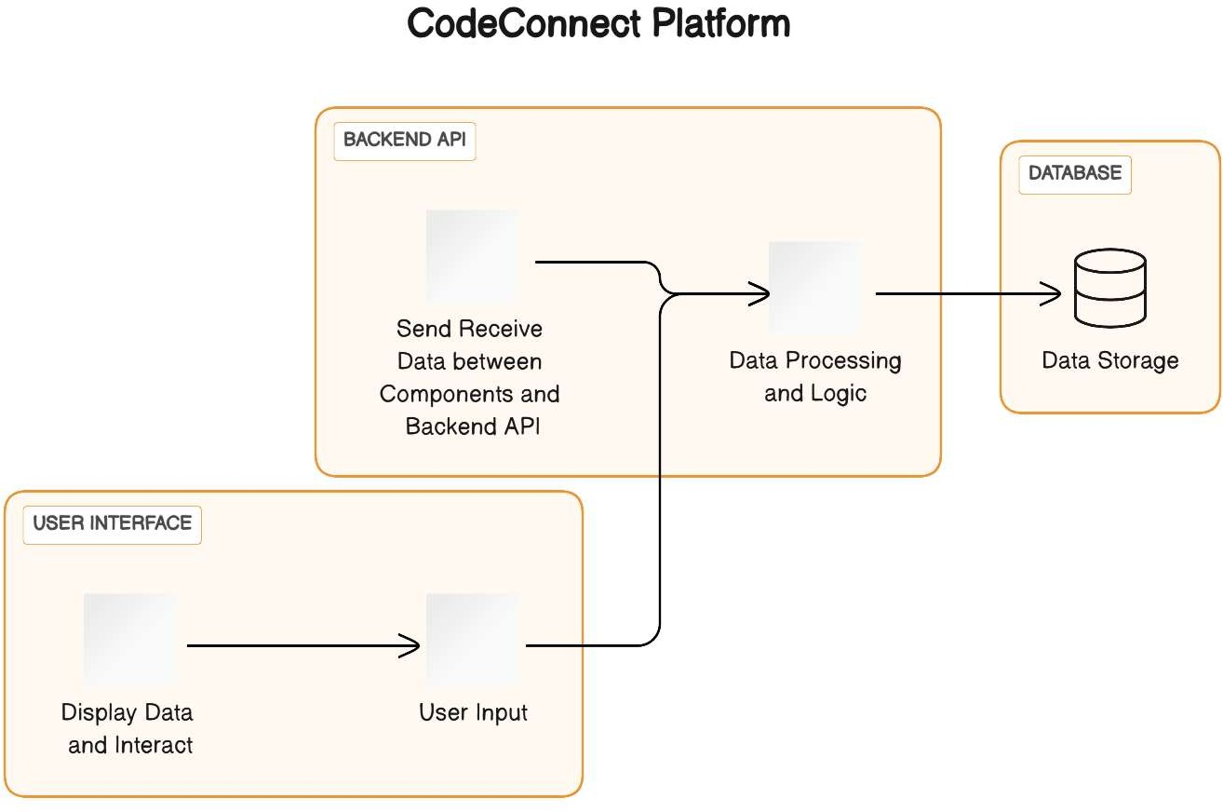

Fig 1: Component Diagram - Represents the high-level components in the system and their interactions

### Sequence Diagram

Purpose : Displays the chronological sequence of interactions between component

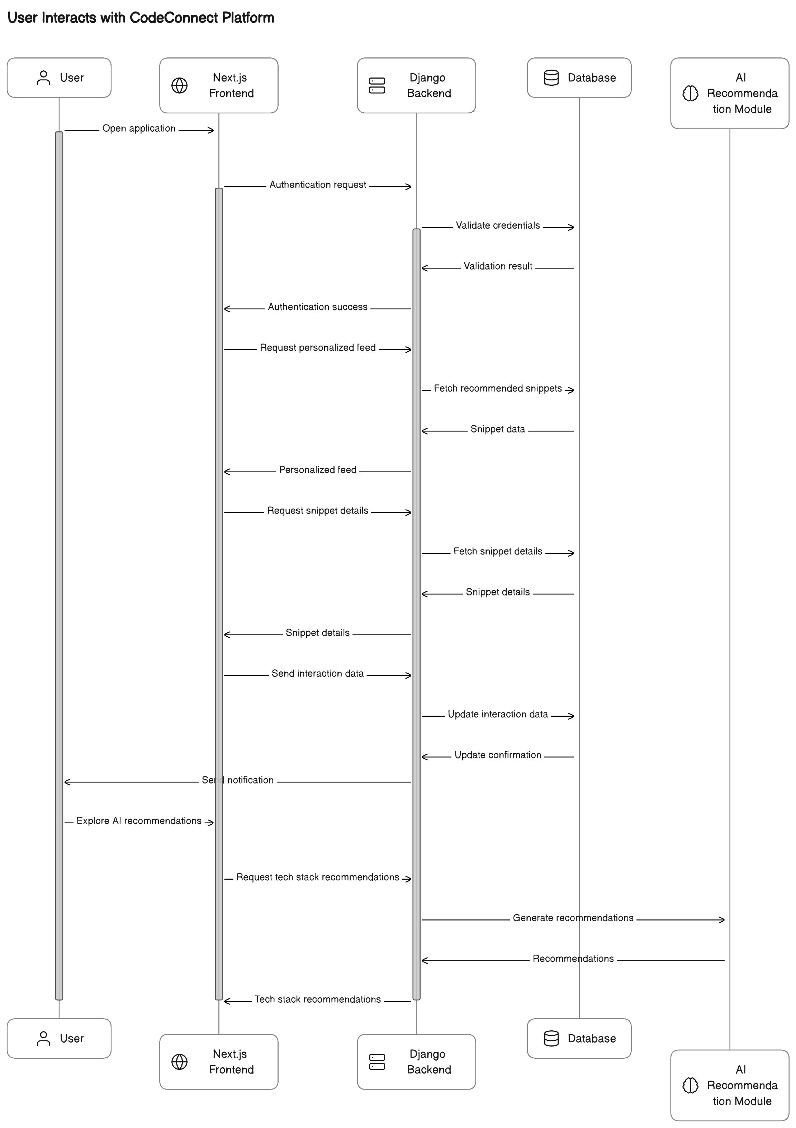

Fig 2 : Sequence Diagram - Displays the chronological sequence of interactions between component

## 6. DATABASE DESIGN

### Database Schema

CodeConnect employs a hybrid database approach, integrating both MySQL and MongoDB to cater to diverse data requirements.

##### User Management

* **Attributes:**
  + UserID (Primary Key)
  + Username
  + Email
  + Password
  + ProfilePicture
  + Bio
  + Location
  + JoinDate

##### Developer Profile Table

* **Attributes:**
  + ProfileID (Primary Key)
  + UserID (Foreign Key referencing User)
  + Skills
  + Certifications
  + Education
  + WorkExperience
  + Projects

##### Tech Stack Badge Table

* **Attributes:**
  + BadgeID (Primary Key)
  + BadgeName
  + Description
  + Image

##### Developer Connection Table

* **Attributes:**
  + ConnectionID (Primary Key)
  + Follower (Foreign Key referencing User)
  + Following (Foreign Key referencing User)

### Collaborative Coding

##### Code Collaboration Table

* **Attributes:**
  + CollaborationID (Primary Key)
  + ProjectName
  + Description
  + StartDate
  + EndDate

##### Code Review Table

* **Attributes:**
  + ReviewID (Primary Key)
  + Reviewer (Foreign Key referencing User)
  + ReviewedCode
  + Comments
  + Rating

##### Coding Challenges Table

* **Attributes:**
  + ChallengeID (Primary Key)
  + Title
  + Description
  + StartDate
  + EndDate
  + Participants (Many-to-Many relationship with User)

##### Code Snippet Table

* **Attributes:**
  + SnippetID (Primary Key)
  + Code
  + Language
  + Description
  + Author (Foreign Key referencing User)

### Events and Opportunities

##### Virtual Tech Events Table

* **Attributes:**
  + EventID (Primary Key)
  + EventName
  + Description
  + Date
  + Speakers (Many-to-Many relationship with User)

##### Job Opportunities Table

* **Attributes:**
  + JobID (Primary Key)
  + Position
  + Description
  + Requirements
  + Company
  + Location
  + ContactEmail

##### Mentorship Program Table

* **Attributes:**
  + MentorshipID (Primary Key)
  + Mentor (Foreign Key referencing User)
  + Mentee (Foreign Key referencing User)
  + StartDate
  + EndDate

### Content Creation

##### Blog Post Table

* **Attributes:**
  + PostID (Primary Key)
  + Title
  + Content
  + Author (Foreign Key referencing User)
  + Date

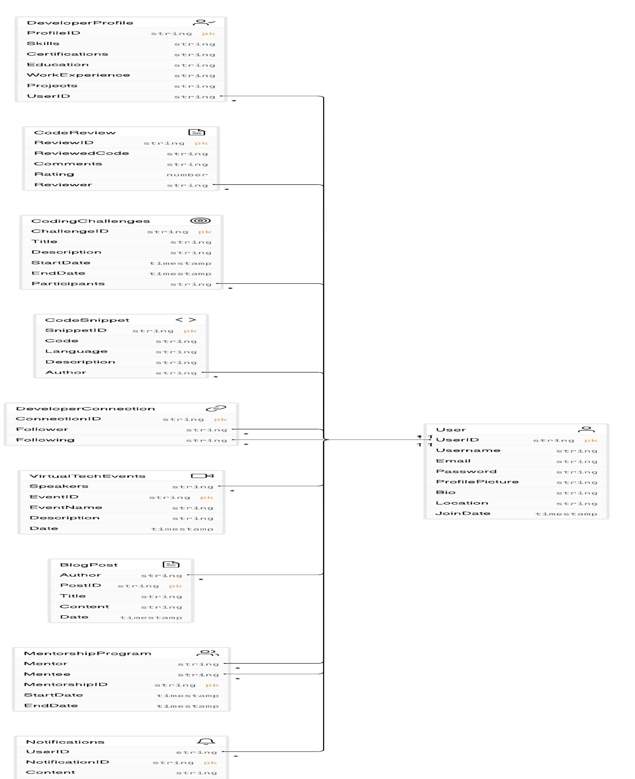

Fig 3: ER Diagram

## SYSTEM QUALITY ATTRIBUTES

### Maintainability

Maintainability is a key aspect of CareConnect’s design, ensuring that the system can be easily updated, enhanced, and debugged over time.

* + - **Modular Code Structure:** The codebase is organized into modular components and follows best practices, making it easier for developers to understand, modify, and extend functionalities.
    - **Documentation:** Comprehensive documentation is provided for both backend and frontend code, outlining the architecture, API endpoints, and data models. This documentation aids developers in maintaining and updating the system.
    - **Version Control:** Git is used for version control, allowing developers to track changes, collaborate seamlessly, and roll back to previous versions if needed.

### Portability

CodeConnect is designed to be portable across different environments and platforms.

* + - **Containerization:** Docker containers encapsulate the application and its dependencies, ensuring consistent behavior across diverse environments, from local development setups to production servers.
    - **Platform-Agnostic Frontend:** The Next.js frontend is developed to be platform-agnostic, providing a responsive user interface across various devices and browsers.

### Testability

A robust testing strategy is implemented to ensure the reliability and correctness of CodeConnect.

* + - **Unit Testing:** Backend and frontend components are subjected to unit tests to verify individual functionalities.
    - **Integration Testing:** The interaction between different modules is thoroughly tested to identify and address any issues that may arise from the integration of components.
    - **User Acceptance Testing (UAT):** Beta testing involving actual users is conducted to gather feedback, identify usability issues, and ensure the platform meets user expectations.

## EXTERNAL DEPENDENCIES

### Third-Party APIs and Services

CodeConnect integrates with several third-party APIs and services to enhance its functionality and provide a seamless user experience.

* + - **GitHub API:** Integrated for user authentication and to fetch repositories, showcasing developers’ projects on their profiles.
    - **MongoDB Atlas:** Utilized to manage and host the MongoDB database, ensuring scalable and reliable storage for unstructured data.
    - **AWS S3 (Simple Storage Service):** Used for storing and serving media files, including user avatars and images in blog posts.

### Integration with Other Platforms

CodeConnect is designed to integrate with popular platforms to provide a connected and enriched experience for users.

* + - **LinkedIn Integration:** Allows users to import LinkedIn profiles, making it easier to set up their CodeConnect profiles and connect with professional contacts.
    - **Tech Stack Recommendation API:** Integrates with an external API that utilizes machine learning algorithms to recommend relevant tech stacks based on users’ skills and interests

## IMPLEMENTATION PLAN

* 1. **Gantt chart**

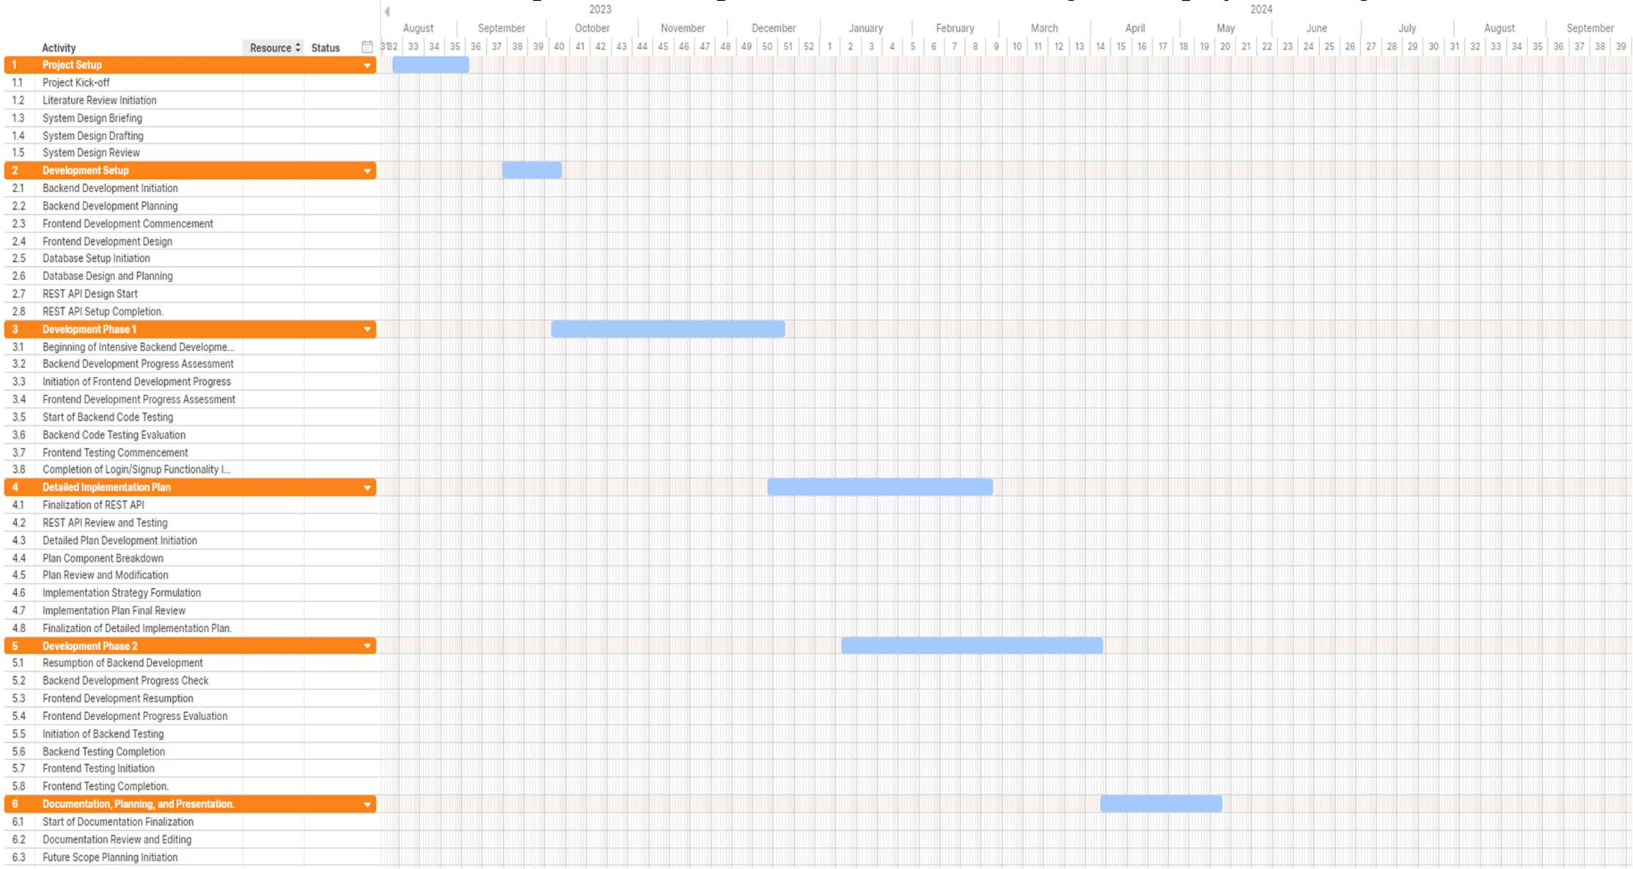The Gantt chart above illustrates the implementation plan that was created using Asana project manager.

## Fig 4 :Gantt chart

## Project Flow Diagram

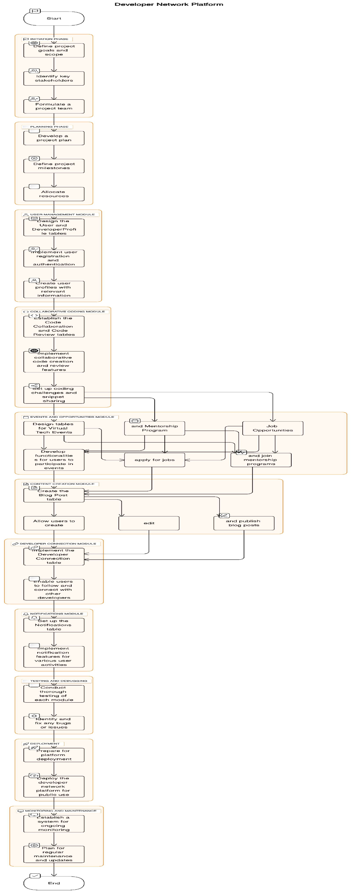



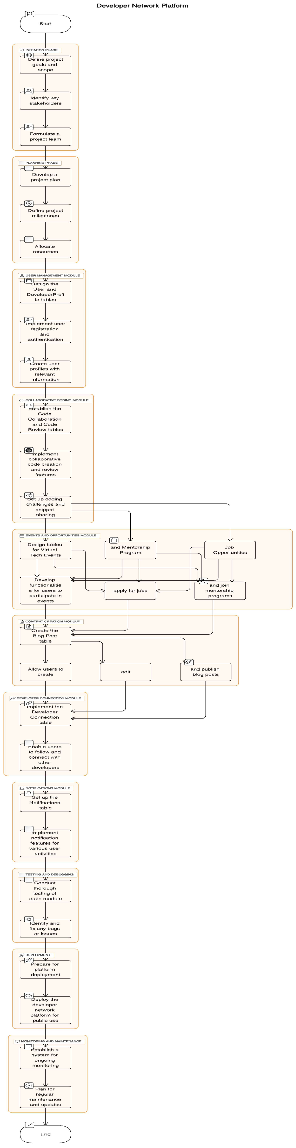



Fig 5 : Project Flow diagram

### Future scope

##### Enhanced Collaboration Features:

* + - * **Real-Time Pair Programming:** Introduce features that facilitate real-time pair programming sessions, allowing developers to collaborate seamlessly on coding projects.

##### Advanced AI Integration:

* + - * **Smart Code Analysis:** Implement advanced AI algorithms for code analysis, providing developers with intelligent insights into code quality, performance, and potential improvements.
      * **Predictive Learning Paths:** Develop AI-driven personalized learning paths, recommending courses, tutorials, and resources based on individual coding journeys and goals.

##### Extended Mentorship Programs:

* + - * **Specialized Mentorship Tracks:** Expand the mentorship program to include specialized tracks such as career guidance, technology-specific mentoring, and project-specific mentorship.

##### Global Tech Events and Conferences:

* + - * **Physical and Hybrid Events:** Organize physical or hybrid (virtual and physical) tech events and conferences, bringing together developers, industry experts, and thought leaders from around the world.

##### Diversification of Content:

* + - * **Multimedia Content Sharing:** Allow developers to share not only code snippets but also multimedia content like video tutorials, webinars, and interactive coding demonstrations.

##### Open Source Collaboration Hub:

* + - * **Integration with GitHub and GitLab:** Strengthen the integration with popular version control platforms, enhancing the platform's role as a hub for open-source collaboration.

##### Career Development Hub:

* + - * **Soft Skills Development:** Introduce features focusing on the development of soft skills, such as communication, teamwork, and project management, to enhance the holistic growth of developers.

##### Global Community Engagement:

* + - * **Localization and Multilingual Support:** Enable localization and multilingual support to make the platform accessible to developers worldwide, fostering a truly global community.

##### Tech Trends and Emerging Technologies:

* + - * **Dedicated Sections for Emerging Tech:** Include dedicated sections or communities for emerging technologies like blockchain, artificial intelligence, and Internet of Things (IoT).

##### Incorporation of Feedback Mechanisms:

* + - * **User Feedback Loops:** Implement robust mechanisms for collecting user feedback and suggestions, ensuring continuous improvement and alignment with the evolving needs of the community.

##### Collaborative Research Initiatives:

* + - * **Research Collaboration Spaces:** Create spaces for collaborative research initiatives, encouraging developers to engage in joint research projects and contribute to cutting-edge advancements in technology.

##### API Marketplace:

* + - * **Developer API Marketplace:** Establish an API marketplace within the platform, allowing developers to share and monetize their APIs, fostering a marketplace for innovation.
  1. User Interface

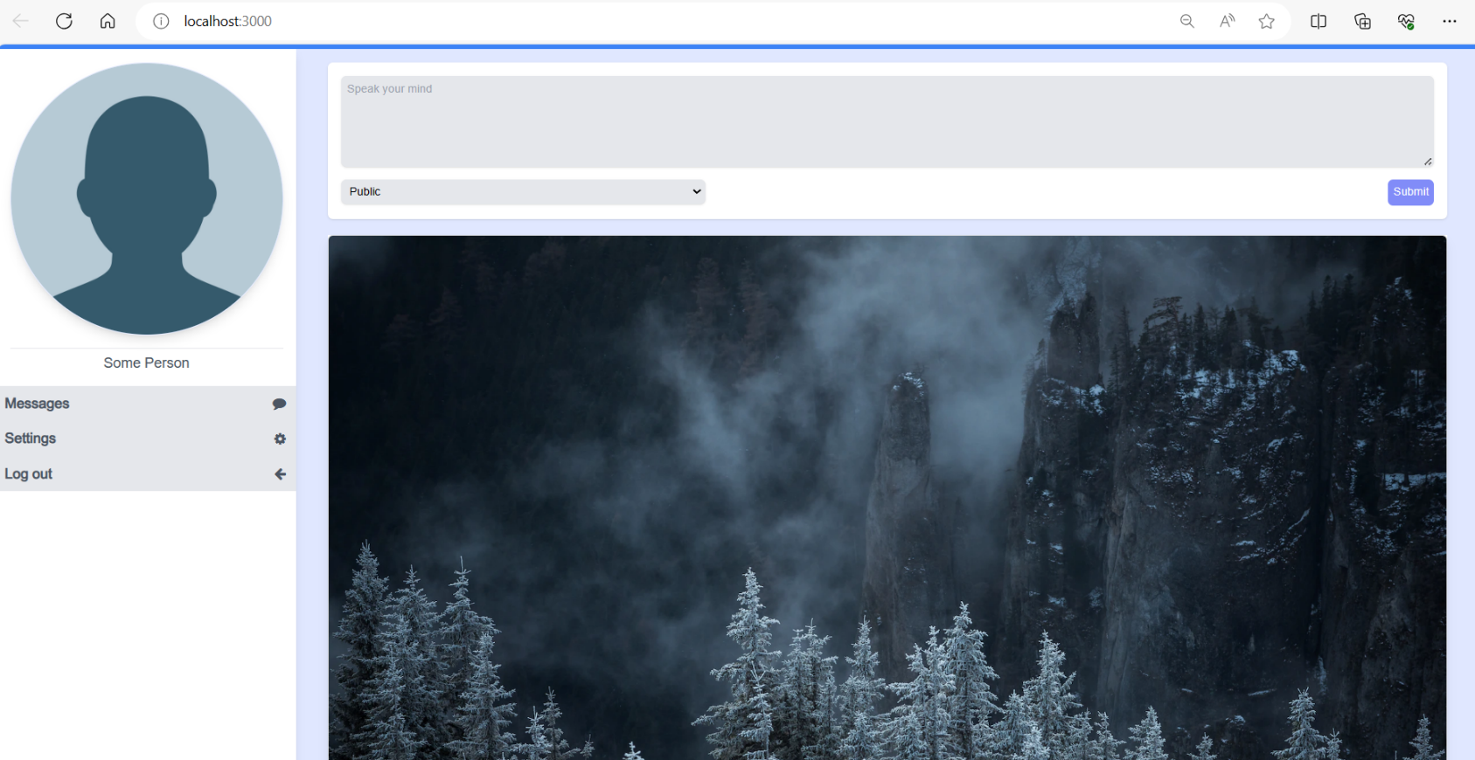Fig 6 : user interface

# CONCLUSION

The CodeConnect project emerges as a dynamic and innovative social platform meticulously crafted for the coding and development community. With an emphasis on fostering collaboration, knowledge sharing, and professional growth, CodeConnect addresses key challenges faced by developers in the contemporary digital landscape.

The project has successfully integrated a myriad of features, from collaborative code editing to real-time project showcases, providing a space where developers can not only demonstrate their technical prowess but also engage in meaningful interactions with their peers. The introduction of Tech Stack Badges adds a gamified element, recognizing and endorsing the diverse skill sets within the community.

The implementation of AI-driven recommendations for job opportunities and tech stacks adds a layer of sophistication, aligning the platform with the evolving landscape of artificial intelligence. The mentorship program further solidifies CodeConnect as a hub for skill development, allowing experienced developers to guide and inspire the next generation of coding enthusiasts.

The project also pays careful attention to the ethical dimension, incorporating secure networking features and privacy settings to ensure user data is handled responsibly. This commitment to ethical practices aligns with the broader educational goals of the engineering program.

As the CodeConnect platform takes shape, it not only meets the outlined objectives but also opens avenues for future growth and expansion. The community-driven nature of the platform, coupled with its adaptability to emerging technologies, positions CodeConnect as a vital resource in the ever-evolving world of coding and development. Through this project, we have not just created a social platform; we have cultivated a digital ecosystem where developers can connect, collaborate, and collectively shape the future of coding.

## ACKNOWLEDGMENTS

We are profoundly grateful to Prof. Reshma Lohar for his expert guidance and continuous encouragement throughout to see that this project rights its target.

We would like to express deepest appreciation towards Dr. Varsha Shah, Principal RCOE, Mumbai and Prof. Anupam Choudhary HOD of Computer Department whose invaluable guidance supported me in this project.

At last, I must express my sincere heartfelt gratitude to all the staff members of Computer Engineering Department who helped us directly or indirectly during this course of work.

Soham Shrikant Manjrekar (UIN:201P018) Shaikh Mudasser Ali (UIN:201P063) Mohammed Baquir Sayed (UIN:201P055) Siddiqui Adaab Husain (UIN: 201P004)

**REFERENCES**

* Begel, A., DeLine, R., & Zimmermann, T. (2010). Social Media for Software Engineering. Conference Paper, November 2010. DOI: 10.1145/1882362.1882370
* Treude, C., Figueira Filho, F., Cleary, B., & Storey, M.-A. (2012). Programming in a Socially Networked World: the Evolution of the Social Programmer. Conference Paper, January 2012.
* Begel, A., & DeLine, R. (2009). Codebook: Social Networking over Code. Conference Paper, January 2009. DOI: 10.1109/ICSE-COMPANION.2009.5070997
* Nasir, J. A., Khatoon, A., & Bharadwaj, S. (2018).Social Media users in India: A Futuristic Approach.IJRAR- International Journal of Research and Analytical Reviews, Volume 5, Issue 4, October–December 2018.E ISSN: 2348 – 1269, Print ISSN: 2349-5138.Received: September 11, 2018; Accepted: October 22, 2018.
* F. P. Brooks, Jr. The Mythical Man-Month. Addison-Wesley Professional, 2nd edition, 1995. [4] J. S. Brown and P. Duguid. Organizational learning and communities-of-practice: Toward a unified view of working, learning, and innovation. Organizational Science, 2(1), 1991.
* M. Cataldo, D. Damian, P. Devanbu, S. Easterbrook, J. Herbsleb, and A. Mockus. 2nd international workshop on socio-technical congruence, May 2009.
* D. Cubranic, J. Singer, and K. S. Booth. Hipikat: A project memory for software development. IEEE Trans. Softw. Eng., 31(6):446–465, 2005. Member-Gail C. Murphy.
* G. Fitzpatrick, P. Marshall, and A. Phillips. Cvs integration with notification and chat: lightweight software team collaboration. In Proceedings of CSCW, pages 49–58, Banff, Alberta, Canada, 2006. ACM Press.
* S. Harrison and P. Dourish. Re-place-ing space: the roles of place and space in collaborative systems. In CSCW ’96: Proceedings of the 1996 ACM conference on Computer supported cooperative work, pages 67–76, New York, NY, USA, 1996. ACM.